Target Shift Worker Manual RGM 2021

R. Miller

Sep 2021

Contents

Contacts 1

Introduction 2

Liquid Targets 3

Fill Liquid Target 4

Empty Liquid Target 8

Target Alarms 11

Calcium Targets 13

Solid Foil Targets 14

Position Solid Foil Targets 16

# Contacts

Bob Miller, 757 822-9586, [rmiller@jlab.org](mailto:rmiller@jlab.org)

Denny Insley, 757 897-9060, [dinsley@jlab.org](mailto:dinsley@jlab.org)

# Introduction

RGM will use multiple targets:

* Liquid targets in a 5 cm long cell
  + H
  + D2
  + 4He
  + argon in a 5 mm long cell
* Calcium targets in a helium purge
  + 40Ca, 1.0 mm thick
  + 48Ca, 1.0 mm thick
* Solid foil targets
  + 4 carbon foils in series, 0.5 mm thick
  + 4 tin foils in series, 0.070 mm thick
  + 1 carbon foil, 2.0 mm thick

The target procedures are listed below by target type.

# Liquid Targets

Use the following procedure to fill and empty the liquid targets. Use the instructions for the type of target gas.

Bob Miller will set up the target system for the gas desired. The shift workers will fill and empty the target using the procedures below.

When the experiment is ready to change to another type of gas, call Bob Miller.

Target Password: clas+2

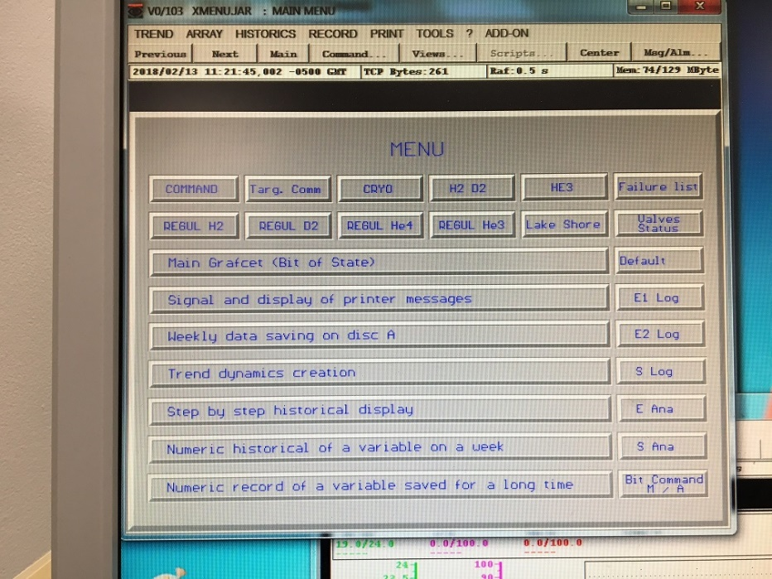

Main Menu

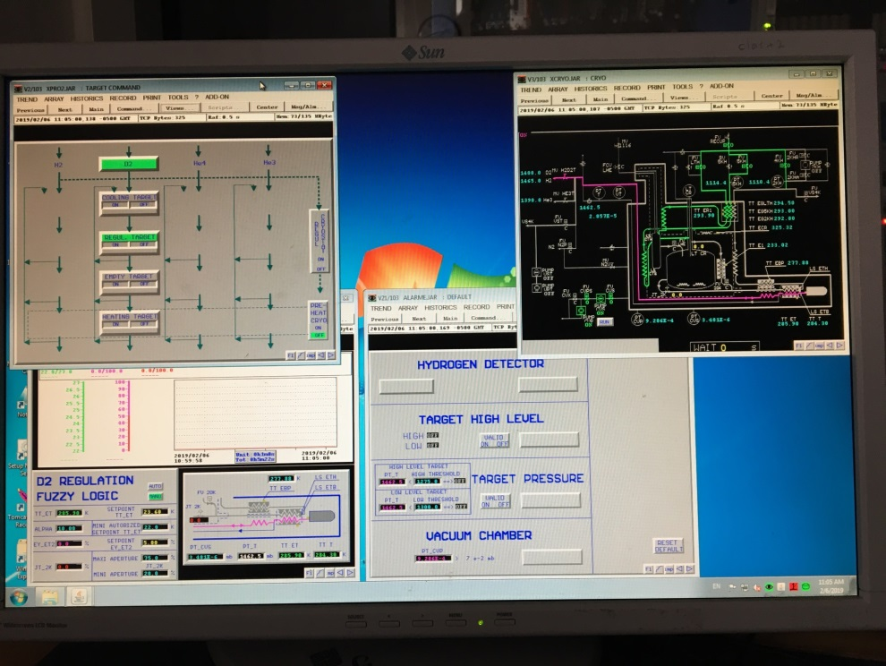

Target

Command

Default

# Fill Liquid Target

Target Password: clas+2

1. The go to page **F3 (Target Command)**: left hand side of screen.
   1. “Regul Target” and “ON” should be green.

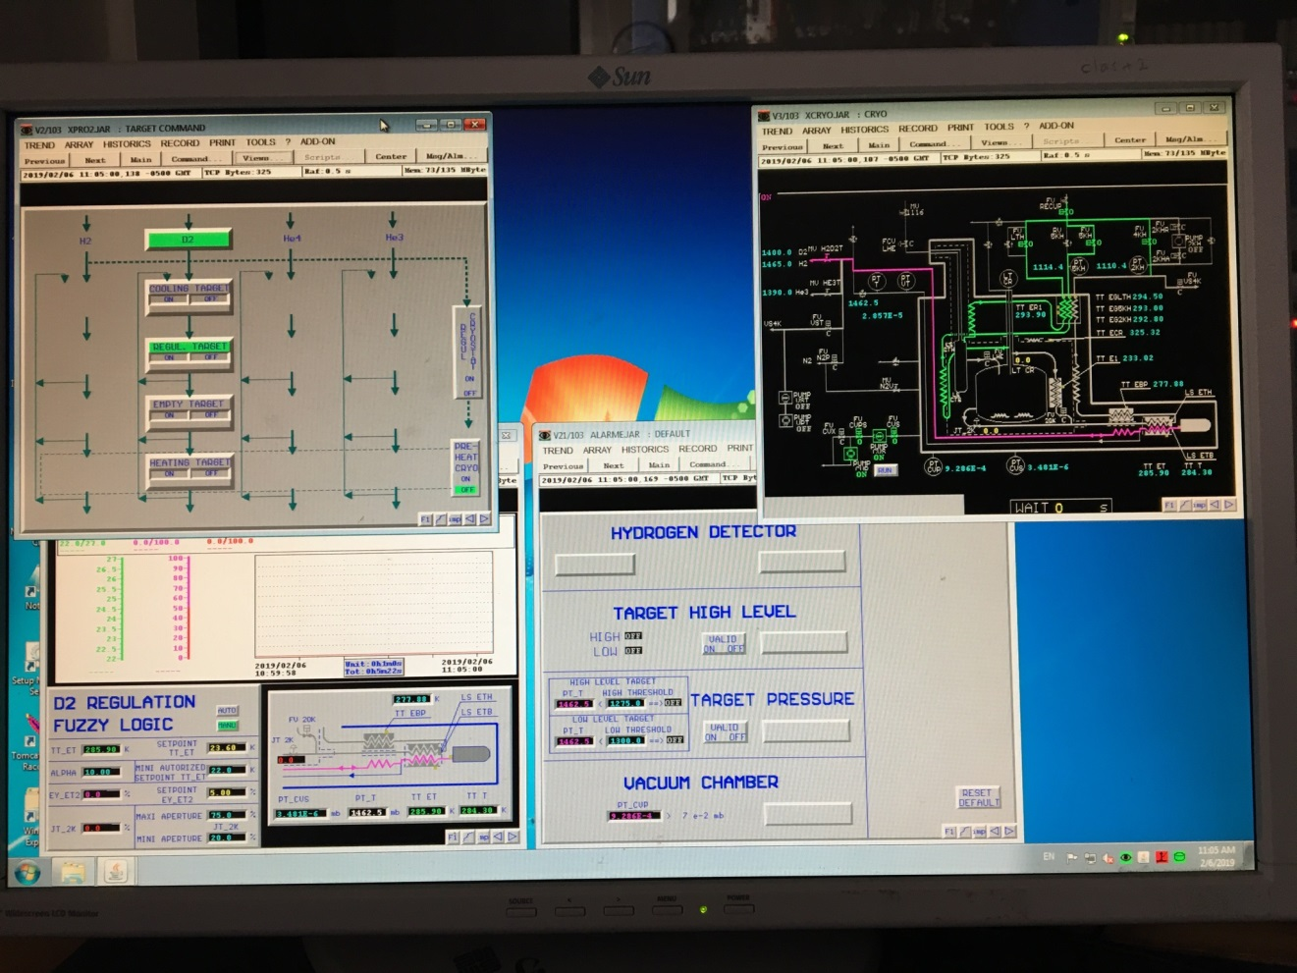

Figure 1: Target Computer

1. Go to regulation page:
   1. D2 - page **F8 (Regul D2)**: lower left side of screen
   2. H2, 4He, Argon – **page F7 (Regul H2)**: lower left side of screen
      1. Change SETPOINT TT_ET to
         1. D2, 23.60 K
         2. H2, 20.65 K
         3. 4He, 4.38 K
         4. Argon, 87.00 K
   3. Target will begin to fill – this should take 30 minutes
   4. Target is full when the TARGET HIGH LEVEL indicators both indicate ON.
      1. Note, target level indicators do not work for argon. Argon target is full when PTT decreases by ~210 mbar.
   5. A full target can also be seen on the EPICS screen
      1. High level in target lights will be green

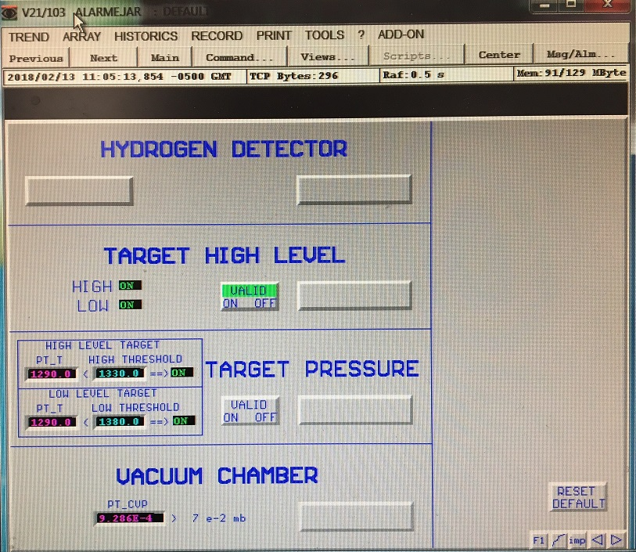

Figure 2: Default Page - Target High Level Indicators On

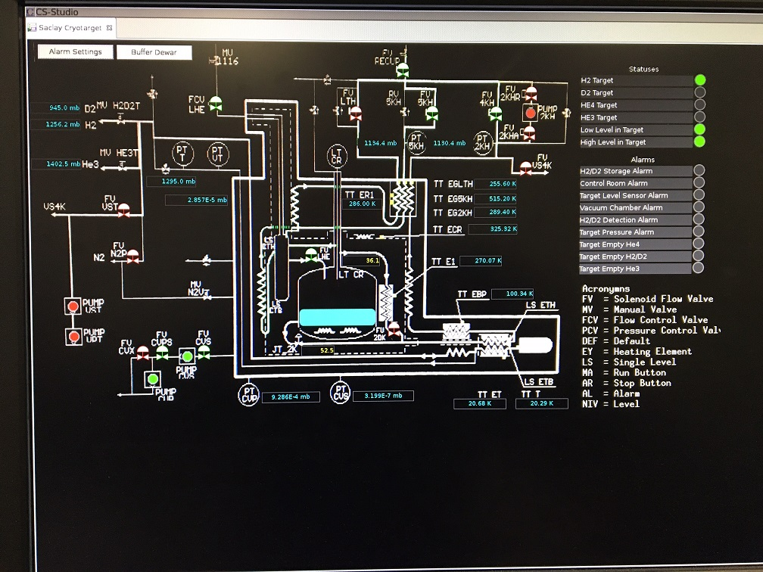

Figure 3: EPICS Screen - Target High Level Indicator On

1. Activate target alarm for D2, H2, and 4He. Omit this step for argon.
   1. Go to page **F1 (Main Menu)**: right hand side of screen. Click on the **Default** box. Click “**ON**” under target high level **valid** box.



Figure 4: Default Page – Turn Alarm On

* 1. This will activate the target alarm.

# Empty Liquid Target

#### 

Target Password: clas+2

1. Disable target alarm
   1. Go to page **F1 (Main Menu)**: right hand side of screen. Click on the **Default** box. Click “**OFF**” under target level **valid** box.



Figure 5: Default Page – Turn Alarm Off

* 1. This will silence the alarm that occurs when the target level decreases.

1. Empty target
   1. Go to regulation page:
      1. D2 - page **F8 (Regul D2)**: lower left side of screen
      2. H2, 4He, Argon – **page F7 (Regul H2)**: lower left side of screen
   2. Change SETPOINT TT_ET to
      * + 1. D2, 35 K
          2. H2, 35 K
          3. 4He, 15 K
          4. Argon, 100 K
   3. Target will empty – this should take 30 minutes
   4. Target is empty when the TARGET HIGH LEVEL indicators both indicate OFF.
      1. Note, target level indicators do not work for argon. Argon target is empty when PTT increases by ~210 mbar.
   5. An empty target can also be seen on the EPICS screen
      1. High level in target lights will be off

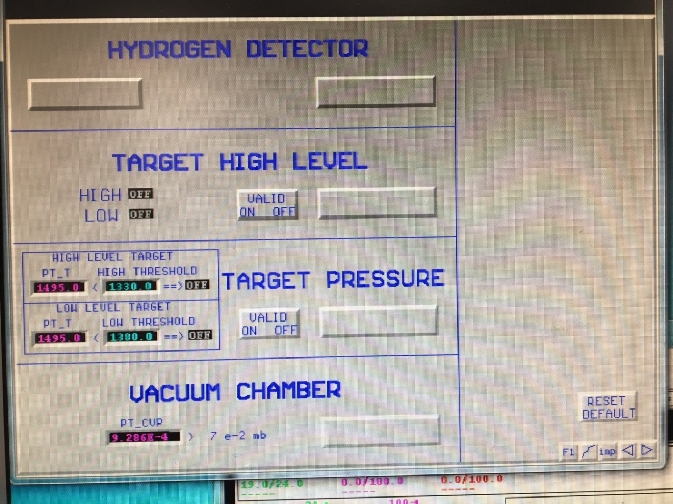

Figure 6: Default Page - Target High Level Indicators Off 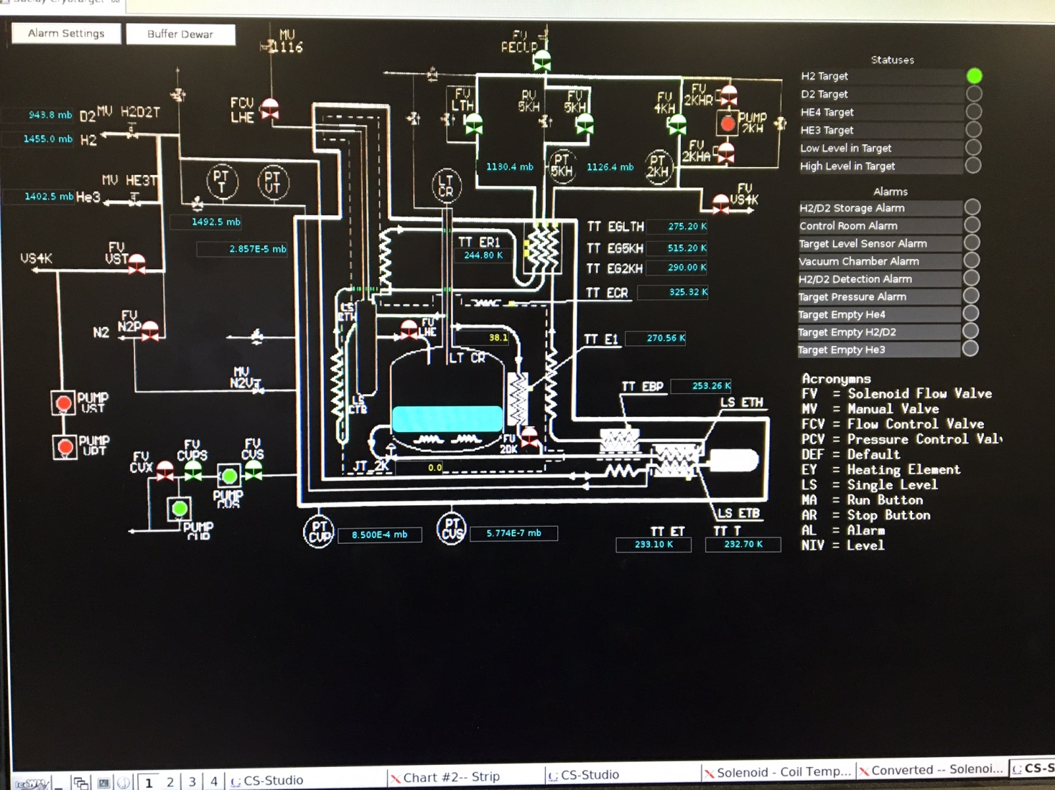

Figure 7: EPICS Screen - Target High Level Indicator Off

# Target Alarms

If a target alarm sounds near the target computer, it could be one of two alarms. Go to page **F1 (Main Menu):** right hand side of screen. Click on the **Default** box. On lower right side of screen, click **reset default** to silence the alarm.

1. **Hydrogen Detector**. This indicates that there is a flammable gas leak at the target or the target rack.
   1. Call Bob Miller 822-9586 or Denny Insley 897-9060
2. **Target Level Alarm**. This alarm sounds when the target is not full. This can happen if there is a cryogenic issue with the ESR. If this is the case, wait until the ESR issue is resolved, then the target should fill automatically.
   1. If there is not an ESR issue, call Bob Miller 822-9586 or Denny Insley 897-9060

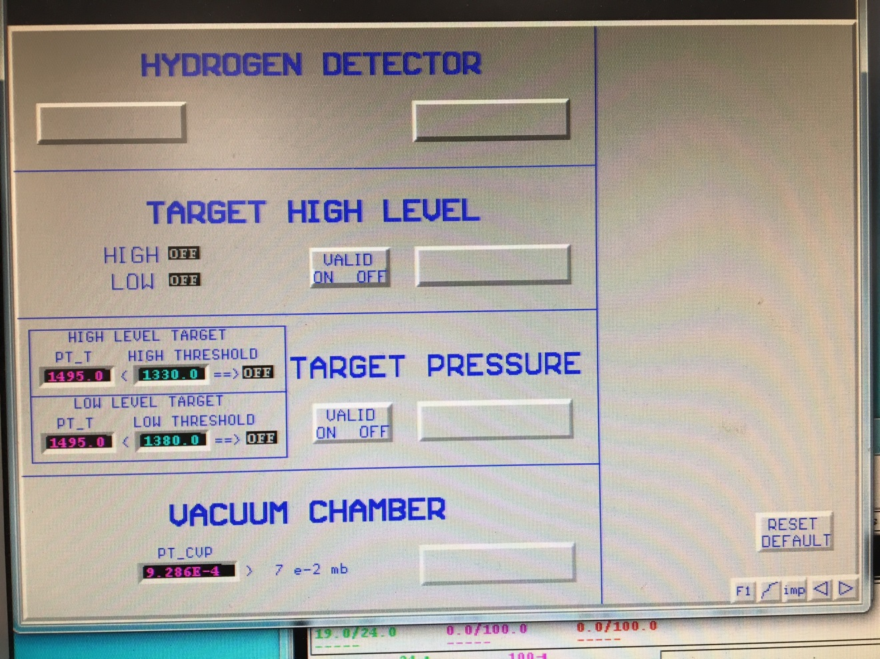

Figure 8: Default Page – Silence the Alarm

If an EPICS target alarm sounds, it could be one of three alarms.

1. Target temperature (TT ET) too low. This indicates that the target liquid is too cold and could freeze.
   1. Go to page **F3 (Target Command):** left hand side of screen.
   2. Click “**Regul Target**” **OFF**
   3. Call Bob Miller 822-9586 or Denny Insley 897-9060

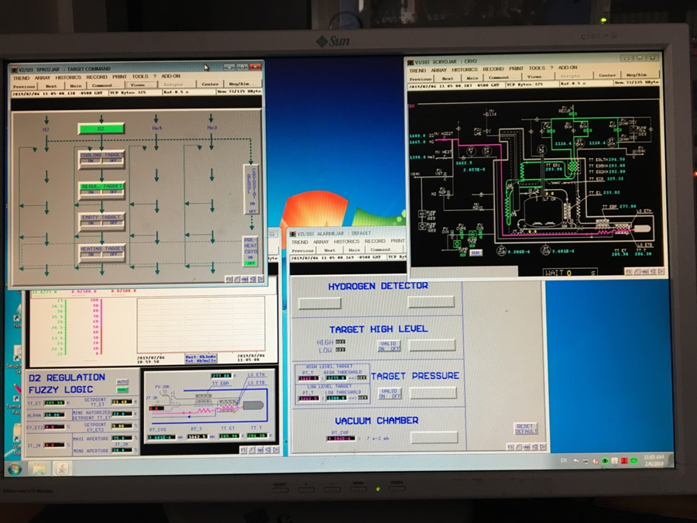

Figure 9: Target Computer Screen

1. Target pressure (PT T) too low. This indicates that the target pressure is below 1000 millibar and air could be drawn into the system.
   1. Call Bob Miller 822-9586 or Denny Insley 897-9060
2. Cryogenic heat exchanger temperature (TT ER1) is too low.
   1. Go to page **F3 (Target Command)**: right hand side of screen.
   2. Click “**Regul Cryostat**” **OFF**
   3. Call Bob Miller 822-9586 or Denny Insley 897-9060

# Calcium Targets

The calcium targets are solid disks, 1 mm thick that are in a helium purge. The disks have a notch removed from the top of the disk to facilitate empty target runs.

Beam on Target

Position the electron beam at the nominal beam centered position to hit the calcium disk with the electron beam.

Empty Target

Position the electron beam up between 3 and 5 mm to miss the calcium disk.

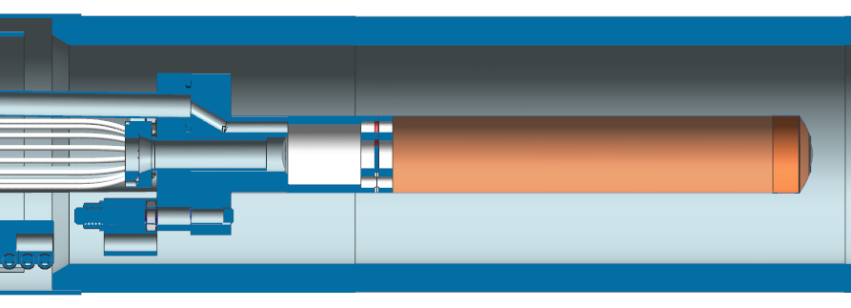

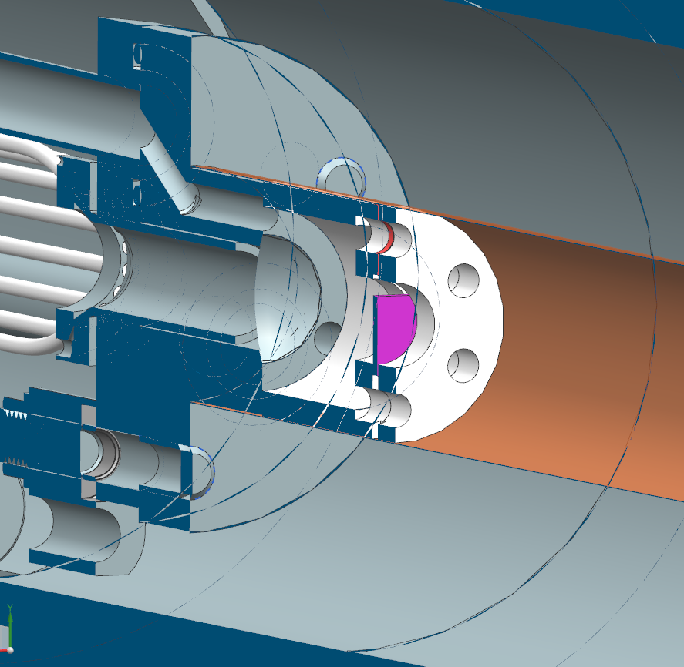

Figure 10: Calcium Target Disk in Purple

# Solid Foil Targets

There are 2 solid foil target assemblies used for RGM:

1. An 8 foil assembly with 4 carbon foils, 0.5 mm thick in series, and 4 tin foils, 0.070 mm thick in series, which are in parallel to the carbon foils
2. One carbon foil, 2 mm thick
   1. This foil is installed with the argon cell and used with the argon target empty

The foils are moved into position by a motor that rotates the assemblies clockwise or anti-clockwise.

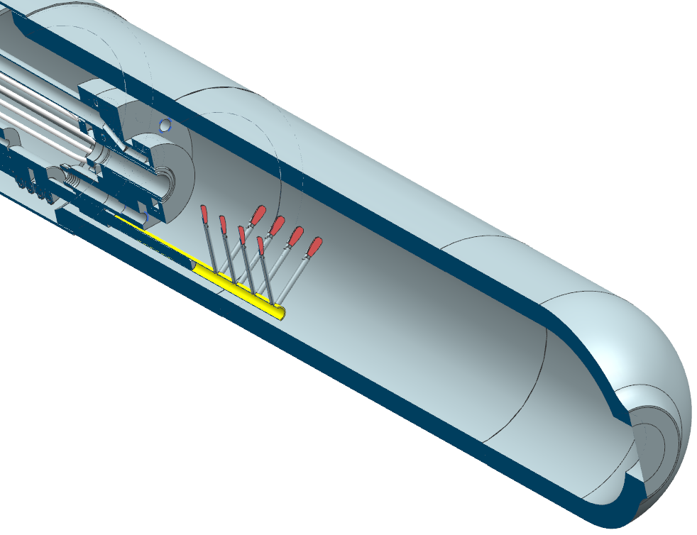

Figure 11: 8 Foil Assembly

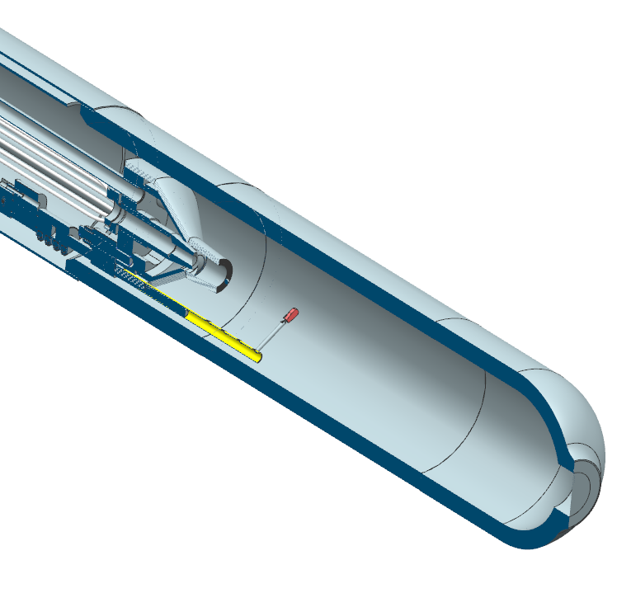

Figure 12: Single Carbon Foil Installed with Liquid Argon Cell

# Position Solid Foil Targets

1. Set foil position to -10 degrees
   1. This will rotate the foil shaft all the way anti-clockwise until it stops at the limit switch
   2. Verify that the limit switch light is on and the indicator resets to zero
2. Set the target position based on the following table:

|  |  |
| --- | --- |
| **Location** | **Degrees (increases clockwise looking downstream)** |
| Anti-clockwise foil limit | 0 |
| 4 tin foils in beam,  2 mm carbon empty target | 2.5 |
| Center, multi foil empty target | 30 |
| 4 carbon foils in beam  2 mm carbon in beam | 57.5 |
| Clockwise foil limit | 60 |

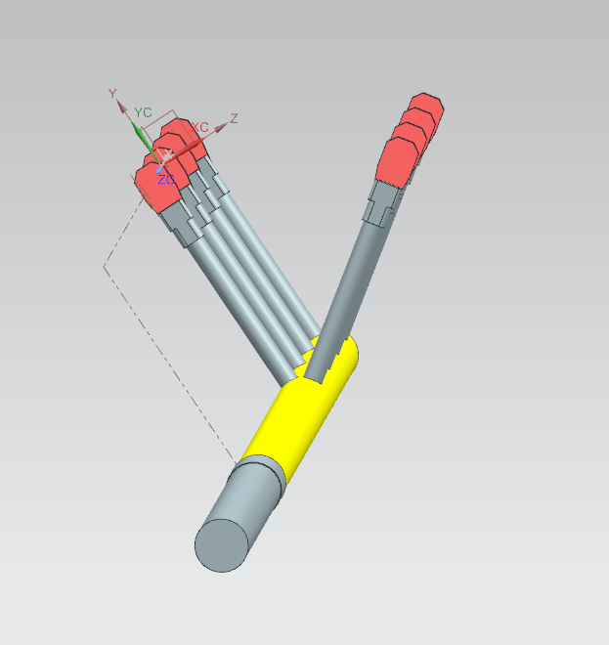

Tin Foils

Carbon Foils

Figure 13: Eight Target Foil Assembly